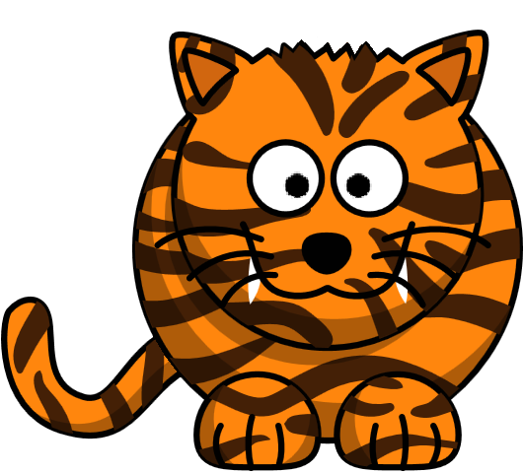 | Bengal  Tiger | Siberian  Tiger | Malayan  Tiger | Caspian  Tiger | Total
Male
Female
Cub
Total

Name………………………………………………… Time…………………………………………

 | Bengal  Tiger | Siberian  Tiger | Malayan  Tiger | Caspian  Tiger | Total
Male
Female
Cub
Total

Name………………………………………………… Time…………………………………………

